|  |  |  |
| --- | --- | --- |
| C:\ProgramData\WebLog Expert Lite\Report\index_files\section_left.gif | **Summary** | C:\ProgramData\WebLog Expert Lite\Report\index_files\section_right.gif |

**Summary**

|  |
| --- |
|  |

|  |  |  |  |  |  |  |  |  |  |  |  |  |  |  |  |  |  |  |  |  |  |  |  |  |  |  |  |  |  |  |  |  |  |  |  |  |  |  |  |  |  |  |  |  |  |  |  |  |
| --- | --- | --- | --- | --- | --- | --- | --- | --- | --- | --- | --- | --- | --- | --- | --- | --- | --- | --- | --- | --- | --- | --- | --- | --- | --- | --- | --- | --- | --- | --- | --- | --- | --- | --- | --- | --- | --- | --- | --- | --- | --- | --- | --- | --- | --- | --- | --- | --- |
| |  |  | | --- | --- | | **Hits** | | | Total Hits | 5,283,177 | | Visitor Hits | 5,283,168 | | Spider Hits | 9 | | Average Hits per Day | 660,397 | | Average Hits per Visitor | 259.35 | | Cached Requests | 0 | | Failed Requests | 87,845 | | **Page Views** | | | Total Page Views | 5,282,956 | | Average Page Views per Day | 660,369 | | Average Page Views per Visitor | 259.34 | | **Visitors** | | | Total Visitors | 20,371 | | Average Visitors per Day | 2,546 | | Total Unique IPs | 16,183 | | **Bandwidth** | | | Total Bandwidth | 12.65 GB | | Visitor Bandwidth | 12.65 GB | | Spider Bandwidth | 484 B | | Average Bandwidth per Day | 1.58 GB | | Average Bandwidth per Hit | 2.51 KB | | Average Bandwidth per Visitor | 651.39 KB | | | |
| C:\ProgramData\WebLog Expert Lite\Report\index_files\section_left.gif | **Daily** | C:\ProgramData\WebLog Expert Lite\Report\index_files\section_right.gif |

**Daily Visitors**  
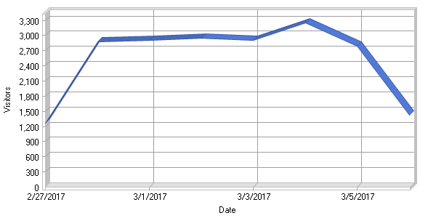

**Daily Activity**

|  |
| --- |
|  |

|  |  |  |  |  |  |  |  |  |  |  |  |  |  |  |  |  |  |  |  |  |  |  |  |  |  |  |  |  |  |  |  |  |  |  |  |  |  |  |  |  |  |  |  |  |  |  |  |  |  |  |  |  |  |  |  |  |  |  |  |  |
| --- | --- | --- | --- | --- | --- | --- | --- | --- | --- | --- | --- | --- | --- | --- | --- | --- | --- | --- | --- | --- | --- | --- | --- | --- | --- | --- | --- | --- | --- | --- | --- | --- | --- | --- | --- | --- | --- | --- | --- | --- | --- | --- | --- | --- | --- | --- | --- | --- | --- | --- | --- | --- | --- | --- | --- | --- | --- | --- | --- | --- |
| |  |  |  |  |  |  | | --- | --- | --- | --- | --- | --- | | **Date** | **Hits** | **Page Views** | **Visitors** | **Average Visit Length** | **Bandwidth (KB)** | | Mon 2/27/2017 | 240,541 | 240,528 | 1,268 | 13:19 | 663,827 | | Tue 2/28/2017 | 1,027,688 | 1,027,657 | 2,883 | 05:20 | 2,736,152 | | Wed 3/1/2017 | 708,181 | 708,153 | 2,910 | 06:50 | 2,553,590 | | Thu 3/2/2017 | 993,087 | 993,053 | 2,954 | 04:39 | 2,220,094 | | Fri 3/3/2017 | 536,036 | 535,986 | 2,900 | 04:56 | 1,614,778 | | Sat 3/4/2017 | 934,884 | 934,858 | 3,244 | 05:34 | 1,483,088 | | Sun 3/5/2017 | 616,668 | 616,640 | 2,789 | 06:04 | 1,324,630 | | Mon 3/6/2017 | 226,092 | 226,081 | 1,423 | 04:01 | 673,284 | | **Total** | **5,283,177** | **5,282,956** | **20,371** | **05:56** | **13,269,447** | |

|  |  |  |
| --- | --- | --- |
| C:\ProgramData\WebLog Expert Lite\Report\index_files\section_left.gif | **By Hour of Day** | C:\ProgramData\WebLog Expert Lite\Report\index_files\section_right.gif |

**Activity by Hour of Day**  
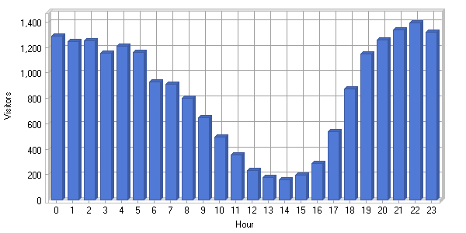

**Activity by Hour of Day**

|  |
| --- |
|  |

|  |  |  |  |  |  |  |  |  |  |  |  |  |  |  |  |  |  |  |  |  |  |  |  |  |  |  |  |  |  |  |  |  |  |  |  |  |  |  |  |  |  |  |  |  |  |  |  |  |  |  |  |  |  |  |  |  |  |  |  |  |  |  |  |  |  |  |  |  |  |  |  |  |  |  |  |  |  |  |  |  |  |  |  |  |  |  |  |  |  |  |  |  |  |  |  |  |  |  |  |  |  |  |  |  |  |  |  |  |  |  |  |  |  |  |  |  |  |  |  |  |  |  |  |  |  |  |  |  |  |  |
| --- | --- | --- | --- | --- | --- | --- | --- | --- | --- | --- | --- | --- | --- | --- | --- | --- | --- | --- | --- | --- | --- | --- | --- | --- | --- | --- | --- | --- | --- | --- | --- | --- | --- | --- | --- | --- | --- | --- | --- | --- | --- | --- | --- | --- | --- | --- | --- | --- | --- | --- | --- | --- | --- | --- | --- | --- | --- | --- | --- | --- | --- | --- | --- | --- | --- | --- | --- | --- | --- | --- | --- | --- | --- | --- | --- | --- | --- | --- | --- | --- | --- | --- | --- | --- | --- | --- | --- | --- | --- | --- | --- | --- | --- | --- | --- | --- | --- | --- | --- | --- | --- | --- | --- | --- | --- | --- | --- | --- | --- | --- | --- | --- | --- | --- | --- | --- | --- | --- | --- | --- | --- | --- | --- | --- | --- | --- | --- | --- | --- | --- |
| |  |  |  |  |  | | --- | --- | --- | --- | --- | | **Hour** | **Hits** | **Page Views** | **Visitors** | **Bandwidth (KB)** | | 00:00 - 00:59 | 246,665 | 246,651 | 1,288 | 653,549 | | 01:00 - 01:59 | 249,527 | 249,510 | 1,247 | 660,132 | | 02:00 - 02:59 | 240,858 | 240,838 | 1,255 | 657,717 | | 03:00 - 03:59 | 236,170 | 236,152 | 1,155 | 659,829 | | 04:00 - 04:59 | 231,951 | 231,941 | 1,211 | 589,584 | | 05:00 - 05:59 | 225,018 | 225,006 | 1,162 | 526,884 | | 06:00 - 06:59 | 213,077 | 213,071 | 928 | 587,038 | | 07:00 - 07:59 | 252,154 | 252,143 | 910 | 780,562 | | 08:00 - 08:59 | 276,840 | 276,837 | 803 | 763,691 | | 09:00 - 09:59 | 301,240 | 301,238 | 648 | 677,516 | | 10:00 - 10:59 | 245,687 | 245,679 | 497 | 552,072 | | 11:00 - 11:59 | 269,607 | 269,604 | 355 | 557,979 | | 12:00 - 12:59 | 204,189 | 204,184 | 232 | 369,947 | | 13:00 - 13:59 | 150,958 | 150,954 | 176 | 271,930 | | 14:00 - 14:59 | 110,403 | 110,400 | 158 | 202,722 | | 15:00 - 15:59 | 137,877 | 137,877 | 198 | 226,160 | | 16:00 - 16:59 | 143,407 | 143,407 | 286 | 246,999 | | 17:00 - 17:59 | 148,109 | 148,099 | 539 | 322,258 | | 18:00 - 18:59 | 177,000 | 176,991 | 874 | 441,485 | | 19:00 - 19:59 | 213,660 | 213,644 | 1,146 | 647,582 | | 20:00 - 20:59 | 230,974 | 230,960 | 1,256 | 696,910 | | 21:00 - 21:59 | 261,864 | 261,854 | 1,339 | 787,770 | | 22:00 - 22:59 | 259,689 | 259,678 | 1,390 | 713,421 | | 23:00 - 23:59 | 256,253 | 256,238 | 1,318 | 675,699 | | **Total** | **5,283,177** | **5,282,956** | **20,371** | **13,269,447** | |

|  |  |  |
| --- | --- | --- |
| C:\ProgramData\WebLog Expert Lite\Report\index_files\section_left.gif | **Pages** | C:\ProgramData\WebLog Expert Lite\Report\index_files\section_right.gif |

**Daily Page Access**  
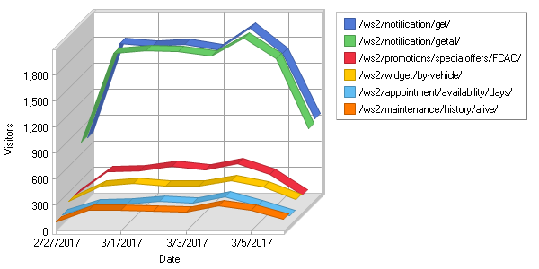

**Most Popular Pages**  
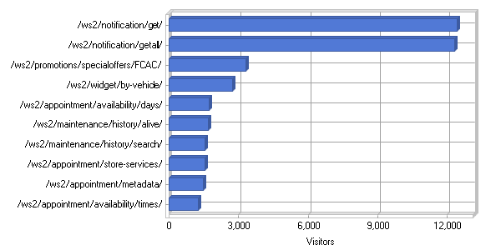

**Most Popular Pages**

|  |
| --- |
|  |

|  |  |  |  |  |  |  |  |  |  |  |  |  |  |  |  |  |  |  |  |  |  |  |  |  |  |  |  |  |  |  |  |  |  |  |  |  |  |  |  |  |  |  |  |  |  |  |  |  |  |  |  |  |  |  |  |  |  |  |  |  |  |  |  |  |  |  |  |  |  |  |  |  |  |  |  |  |  |  |  |  |  |  |  |  |  |  |  |  |  |  |  |  |  |  |  |  |  |  |  |  |  |  |  |  |  |  |  |  |  |  |  |  |  |  |  |  |  |  |  |  |  |  |  |  |  |  |  |  |  |  |  |  |  |  |  |  |  |  |  |  |  |  |  |  |  |  |  |  |  |  |  |  |  |  |  |  |  |  |  |  |  |  |  |  |  |  |  |  |  |  |  |  |  |  |  |  |  |  |  |  |  |  |  |  |  |  |  |  |  |  |  |  |  |  |  |  |  |  |  |  |  |  |  |  |  |  |  |  |  |  |  |  |  |  |  |  |  |  |  |  |  |  |  |  |  |  |  |  |  |  |  |  |  |  |  |  |  |  |  |  |  |  |  |  |  |  |  |  |  |  |  |  |  |  |  |  |  |  |  |  |  |  |  |  |  |  |  |  |  |  |  |  |  |  |  |  |  |  |  |  |  |  |  |  |  |  |  |  |  |  |  |  |  |  |  |  |  |  |  |  |  |  |  |  |  |  |  |  |  |  |  |  |  |  |  |  |  |  |
| --- | --- | --- | --- | --- | --- | --- | --- | --- | --- | --- | --- | --- | --- | --- | --- | --- | --- | --- | --- | --- | --- | --- | --- | --- | --- | --- | --- | --- | --- | --- | --- | --- | --- | --- | --- | --- | --- | --- | --- | --- | --- | --- | --- | --- | --- | --- | --- | --- | --- | --- | --- | --- | --- | --- | --- | --- | --- | --- | --- | --- | --- | --- | --- | --- | --- | --- | --- | --- | --- | --- | --- | --- | --- | --- | --- | --- | --- | --- | --- | --- | --- | --- | --- | --- | --- | --- | --- | --- | --- | --- | --- | --- | --- | --- | --- | --- | --- | --- | --- | --- | --- | --- | --- | --- | --- | --- | --- | --- | --- | --- | --- | --- | --- | --- | --- | --- | --- | --- | --- | --- | --- | --- | --- | --- | --- | --- | --- | --- | --- | --- | --- | --- | --- | --- | --- | --- | --- | --- | --- | --- | --- | --- | --- | --- | --- | --- | --- | --- | --- | --- | --- | --- | --- | --- | --- | --- | --- | --- | --- | --- | --- | --- | --- | --- | --- | --- | --- | --- | --- | --- | --- | --- | --- | --- | --- | --- | --- | --- | --- | --- | --- | --- | --- | --- | --- | --- | --- | --- | --- | --- | --- | --- | --- | --- | --- | --- | --- | --- | --- | --- | --- | --- | --- | --- | --- | --- | --- | --- | --- | --- | --- | --- | --- | --- | --- | --- | --- | --- | --- | --- | --- | --- | --- | --- | --- | --- | --- | --- | --- | --- | --- | --- | --- | --- | --- | --- | --- | --- | --- | --- | --- | --- | --- | --- | --- | --- | --- | --- | --- | --- | --- | --- | --- | --- | --- | --- | --- | --- | --- | --- | --- | --- | --- | --- | --- | --- | --- | --- | --- | --- | --- | --- | --- | --- | --- | --- | --- | --- | --- | --- | --- | --- | --- | --- | --- | --- | --- | --- | --- | --- | --- | --- | --- | --- | --- | --- | --- | --- | --- | --- | --- | --- | --- | --- | --- | --- | --- | --- | --- | --- | --- | --- | --- | --- | --- | --- | --- | --- |
| |  |  |  |  |  |  | | --- | --- | --- | --- | --- | --- | |  | **Page** | **Hits** | **Incomplete Requests** | **Visitors** | **Bandwidth (KB)** | | 1 | [http://www.api-aem.bsro.com/ ws2/notification/get/](http://www.api-aem.bsro.com/ws2/notification/get/) | 14,757 | 0 | 12,416 | 1,311 | | 2 | [http://www.api-aem.bsro.com/ ws2/notification/getall/](http://www.api-aem.bsro.com/ws2/notification/getall/) | 14,248 | 0 | 12,323 | 1,271 | | 3 | [http://www.api-aem.bsro.com/ ws2/promotions/specialoffers/ FCAC/](http://www.api-aem.bsro.com/ws2/promotions/specialoffers/FCAC/) | 16,611 | 0 | 3,327 | 36,190 | | 4 | [http://www.api-aem.bsro.com/ ws2/widget/by-vehicle/](http://www.api-aem.bsro.com/ws2/widget/by-vehicle/) | 3,487 | 0 | 2,725 | 754 | | 5 | [http://www.api-aem.bsro.com/ ws2/appointment/availability/ days/](http://www.api-aem.bsro.com/ws2/appointment/availability/days/) | 50,308 | 0 | 1,739 | 151,770 | | 6 | [http://www.api-aem.bsro.com/ ws2/maintenance/history/ alive/](http://www.api-aem.bsro.com/ws2/maintenance/history/alive/) | 2,256 | 0 | 1,695 | 26 | | 7 | [http://www.api-aem.bsro.com/ ws2/maintenance/history/ search/](http://www.api-aem.bsro.com/ws2/maintenance/history/search/) | 1,987 | 0 | 1,530 | 21,994 | | 8 | [http://www.api-aem.bsro.com/ ws2/appointment/store-services/](http://www.api-aem.bsro.com/ws2/appointment/store-services/) | 37,386 | 0 | 1,530 | 91,252 | | 9 | [http://www.api-aem.bsro.com/ ws2/appointment/metadata/](http://www.api-aem.bsro.com/ws2/appointment/metadata/) | 48,094 | 0 | 1,485 | 8,196 | | 10 | [http://www.api-aem.bsro.com/ ws2/appointment/availability/ times/](http://www.api-aem.bsro.com/ws2/appointment/availability/times/) | 115,655 | 0 | 1,259 | 39,029 | | 11 | [http://www.api-aem.bsro.com/ ws2/store/info/](http://www.api-aem.bsro.com/ws2/store/info/) | 198,226 | 0 | 870 | 213,131 | | 12 | [http://www.api-aem.bsro.com/ ws2/appointment/book/](http://www.api-aem.bsro.com/ws2/appointment/book/) | 11,666 | 0 | 814 | 3,301 | | 13 | [http://www.api-aem.bsro.com/ ws2/promotions/specialoffers/TP/](http://www.api-aem.bsro.com/ws2/promotions/specialoffers/TP/) | 7,770 | 0 | 733 | 17,446 | | 14 | [http://www.api-aem.bsro.com/ ws2/mobile-app-user/authenticate/](http://www.api-aem.bsro.com/ws2/mobile-app-user/authenticate/) | 841 | 0 | 520 | 34 | | 15 | [http://www.api-aem.bsro.com/ ws2/widget/by-vehicle/ 2013/](http://www.api-aem.bsro.com/ws2/widget/by-vehicle/2013/) | 17,150 | 0 | 414 | 45,456 | | 16 | [http://www.api-aem.bsro.com/ ws2/widget/by-vehicle/ 2007/](http://www.api-aem.bsro.com/ws2/widget/by-vehicle/2007/) | 14,377 | 0 | 397 | 39,770 | | 17 | [http://www.api-aem.bsro.com/ ws2/widget/by-vehicle/ 2008/](http://www.api-aem.bsro.com/ws2/widget/by-vehicle/2008/) | 14,480 | 0 | 390 | 40,995 | | 18 | [http://www.api-aem.bsro.com/ ws2/widget/by-vehicle/ 2012/](http://www.api-aem.bsro.com/ws2/widget/by-vehicle/2012/) | 15,685 | 0 | 386 | 43,342 | | 19 | [http://www.api-aem.bsro.com/ ws2/widget/by-vehicle/ 2006/](http://www.api-aem.bsro.com/ws2/widget/by-vehicle/2006/) | 13,781 | 0 | 385 | 38,907 | | 20 | [http://www.api-aem.bsro.com/ ws2/widget/by-vehicle/ 2010/](http://www.api-aem.bsro.com/ws2/widget/by-vehicle/2010/) | 13,256 | 0 | 375 | 36,027 | | 21 | [http://www.api-aem.bsro.com/ ws2/widget/by-vehicle/ 2005/](http://www.api-aem.bsro.com/ws2/widget/by-vehicle/2005/) | 13,342 | 0 | 372 | 36,935 | | 22 | [http://www.api-aem.bsro.com/ ws2/widget/by-vehicle/ 2011/](http://www.api-aem.bsro.com/ws2/widget/by-vehicle/2011/) | 14,478 | 0 | 369 | 38,414 | | 23 | [http://www.api-aem.bsro.com/ ws2/widget/by-vehicle/ 2009/](http://www.api-aem.bsro.com/ws2/widget/by-vehicle/2009/) | 12,317 | 0 | 362 | 33,446 | | 24 | [http://www.api-aem.bsro.com/ ws2/widget/by-vehicle/ 2014/](http://www.api-aem.bsro.com/ws2/widget/by-vehicle/2014/) | 17,565 | 0 | 362 | 46,148 | | 25 | [http://www.api-aem.bsro.com/ ws2/widget/by-vehicle/ 2004/](http://www.api-aem.bsro.com/ws2/widget/by-vehicle/2004/) | 12,679 | 0 | 344 | 35,889 | | 26 | [http://www.api-aem.bsro.com/ ws2/widget/by-vehicle/ 2015/](http://www.api-aem.bsro.com/ws2/widget/by-vehicle/2015/) | 16,149 | 0 | 339 | 41,767 | | 27 | [http://www.api-aem.bsro.com/ ws2/notification/update/](http://www.api-aem.bsro.com/ws2/notification/update/) | 573 | 0 | 323 | 33 | | 28 | [http://www.api-aem.bsro.com/ ws2/widget/by-vehicle/ 2003/](http://www.api-aem.bsro.com/ws2/widget/by-vehicle/2003/) | 11,216 | 0 | 320 | 30,441 | | 29 | [http://www.api-aem.bsro.com/ ws2/widget/by-vehicle/ 2002/](http://www.api-aem.bsro.com/ws2/widget/by-vehicle/2002/) | 10,473 | 0 | 315 | 29,109 | | 30 | [http://www.api-aem.bsro.com/ ws2/widget/by-vehicle/ 2016/](http://www.api-aem.bsro.com/ws2/widget/by-vehicle/2016/) | 13,411 | 0 | 305 | 33,963 | | 31 | [http://www.api-aem.bsro.com/ ws2/store/locator/zip/ 60605/FCAC/](http://www.api-aem.bsro.com/ws2/store/locator/zip/60605/FCAC/) | 875 | 0 | 278 | 10,948 | | 32 | [http://www.api-aem.bsro.com/ ws2/widget/by-vehicle/ 2000/](http://www.api-aem.bsro.com/ws2/widget/by-vehicle/2000/) | 8,381 | 0 | 268 | 21,498 | | 33 | [http://www.api-aem.bsro.com/ ws2/widget/by-vehicle/ 2001/](http://www.api-aem.bsro.com/ws2/widget/by-vehicle/2001/) | 9,140 | 0 | 266 | 23,934 | | 34 | [http://www.api-aem.bsro.com/ ws2/store/locator/address/ FCAC/](http://www.api-aem.bsro.com/ws2/store/locator/address/FCAC/) | 15,434 | 0 | 260 | 369,909 | | 35 | [http://www.api-aem.bsro.com/ ws2/widget/by-vehicle/ 2017/](http://www.api-aem.bsro.com/ws2/widget/by-vehicle/2017/) | 5,980 | 0 | 258 | 11,486 | | 36 | [http://www.api-aem.bsro.com/ ws2/widget/by-vehicle/ 1999/](http://www.api-aem.bsro.com/ws2/widget/by-vehicle/1999/) | 7,848 | 0 | 252 | 19,613 | | 37 | [http://www.api-aem.bsro.com/ ws2/mobile-app-user/register/](http://www.api-aem.bsro.com/ws2/mobile-app-user/register/) | 250 | 0 | 248 | 12 | | 38 | [http://www.api-aem.bsro.com/ ws2/widget/by-vehicle/ 1997/](http://www.api-aem.bsro.com/ws2/widget/by-vehicle/1997/) | 6,330 | 0 | 247 | 16,195 | | 39 | [http://www.api-aem.bsro.com/ ws2/widget/by-vehicle/ 1998/](http://www.api-aem.bsro.com/ws2/widget/by-vehicle/1998/) | 6,919 | 0 | 236 | 17,375 | | 40 | [http://www.api-aem.bsro.com/ ws2/promotions/specialoffers/WWT/](http://www.api-aem.bsro.com/ws2/promotions/specialoffers/WWT/) | 3,149 | 0 | 225 | 9,839 | | 41 | [http://www.api-aem.bsro.com/ ws2/ipinfo/ip/](http://www.api-aem.bsro.com/ws2/ipinfo/ip/) | 569,981 | 0 | 224 | 40,039 | | 42 | [http://www.api-aem.bsro.com/ ws2/promotions/specialoffers/HT/](http://www.api-aem.bsro.com/ws2/promotions/specialoffers/HT/) | 3,355 | 0 | 223 | 9,697 | | 43 | [http://www.api-aem.bsro.com/ ws2/widget/by-vehicle/ 1996/](http://www.api-aem.bsro.com/ws2/widget/by-vehicle/1996/) | 5,989 | 0 | 222 | 14,636 | | 44 | [http://www.api-aem.bsro.com/ ws2/mobile-app-user/check-data/](http://www.api-aem.bsro.com/ws2/mobile-app-user/check-data/) | 254 | 0 | 221 | 9 | | 45 | [http://www.api-aem.bsro.com/ ws2/widget/by-vehicle/ 1995/](http://www.api-aem.bsro.com/ws2/widget/by-vehicle/1995/) | 5,912 | 0 | 216 | 15,139 | | 46 | [http://www.api-aem.bsro.com/ ws2/widget/by-vehicle/ 1994/](http://www.api-aem.bsro.com/ws2/widget/by-vehicle/1994/) | 5,502 | 0 | 216 | 14,445 | | 47 | [http://www.api-aem.bsro.com/ ws2/store/services/](http://www.api-aem.bsro.com/ws2/store/services/) | 132,336 | 0 | 209 | 20,945 | | 48 | [http://www.api-aem.bsro.com/ ws2/widget/by-vehicle/ 1993/](http://www.api-aem.bsro.com/ws2/widget/by-vehicle/1993/) | 5,241 | 0 | 208 | 13,515 | | 49 | [http://www.api-aem.bsro.com/ ws2/vehicle/battery/options/ year-make-model-engine/ engine-sizes/](http://www.api-aem.bsro.com/ws2/vehicle/battery/options/year-make-model-engine/engine-sizes/) | 4,201 | 0 | 208 | 310 | | 50 | [http://www.api-aem.bsro.com/ ws2/tires/quote/update/](http://www.api-aem.bsro.com/ws2/tires/quote/update/) | 36,089 | 0 | 207 | 1,867 | |  | **Subtotal** | **1,567,390** | **0** | **N/A** | **1,787,783** | |  | **Total** | **5,195,330** | **0** | **N/A** | **13,254,050** | |

|  |  |  |
| --- | --- | --- |
| C:\ProgramData\WebLog Expert Lite\Report\index_files\section_left.gif | **Images** | C:\ProgramData\WebLog Expert Lite\Report\index_files\section_right.gif |

**Daily Image Access**  
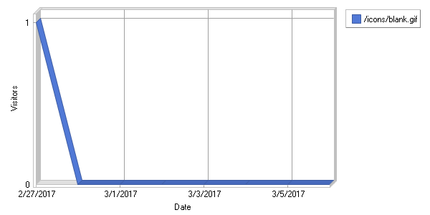

**Most Requested Images**  
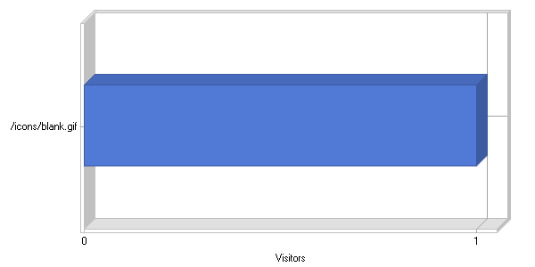

**Most Requested Images**

|  |
| --- |
|  |

|  |  |  |  |  |  |  |  |  |  |  |  |  |  |  |  |  |  |  |  |  |
| --- | --- | --- | --- | --- | --- | --- | --- | --- | --- | --- | --- | --- | --- | --- | --- | --- | --- | --- | --- | --- |
| |  |  |  |  |  |  | | --- | --- | --- | --- | --- | --- | |  | **Image** | **Hits** | **Incomplete Requests** | **Visitors** | **Bandwidth (KB)** | | 1 | [http://www.api-aem.bsro.com/ icons/blank.gif](http://www.api-aem.bsro.com/icons/blank.gif) | 1 | 0 | 1 | 0 | |  | **Total** | **1** | **0** | **N/A** | **0** | | | |
| C:\ProgramData\WebLog Expert Lite\Report\index_files\section_left.gif | **Directories** | C:\ProgramData\WebLog Expert Lite\Report\index_files\section_right.gif |

**Daily Directory Access**  
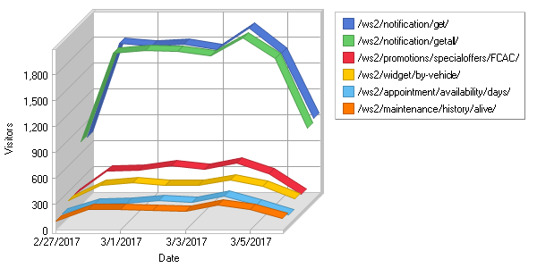

**Most Requested Directories**  
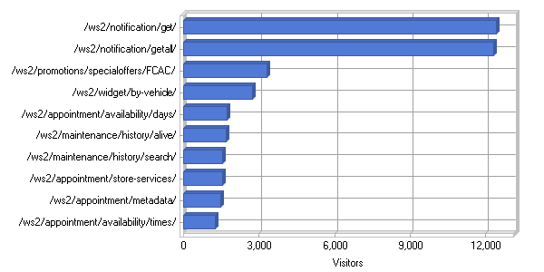

**Most Requested Directories**

|  |
| --- |
|  |

|  |  |  |  |  |  |  |  |  |  |  |  |  |  |  |  |  |  |  |  |  |  |  |  |  |  |  |  |  |  |  |  |  |  |  |  |  |  |  |  |  |  |  |  |  |  |  |  |  |  |  |  |  |  |  |  |  |  |  |  |  |  |  |  |  |  |  |  |  |  |  |  |  |  |  |  |  |  |  |  |  |  |  |  |  |  |  |  |  |  |  |  |  |  |  |  |  |  |  |  |  |  |  |  |  |  |  |  |  |  |  |  |  |  |  |  |  |  |  |  |  |  |  |  |  |  |  |  |  |  |  |  |  |  |  |  |  |  |  |  |  |  |  |  |  |  |  |  |  |  |  |  |  |  |  |  |  |  |  |  |  |  |  |  |  |  |  |  |  |  |  |  |  |  |  |  |  |  |  |  |  |  |  |  |  |  |  |  |  |  |  |  |  |  |  |  |  |  |  |  |  |  |  |  |  |  |  |  |  |  |  |  |  |  |  |  |  |  |  |  |  |  |  |  |  |  |  |  |  |  |  |  |  |  |  |  |  |  |  |  |  |  |  |  |  |  |  |  |  |  |  |  |  |  |  |  |  |  |  |  |  |  |  |  |  |  |  |  |  |  |  |  |  |  |  |  |  |  |  |  |  |  |  |  |  |  |  |  |  |  |  |  |  |  |  |  |  |  |  |  |  |  |  |  |  |  |  |  |  |  |  |  |  |  |  |  |  |  |  |
| --- | --- | --- | --- | --- | --- | --- | --- | --- | --- | --- | --- | --- | --- | --- | --- | --- | --- | --- | --- | --- | --- | --- | --- | --- | --- | --- | --- | --- | --- | --- | --- | --- | --- | --- | --- | --- | --- | --- | --- | --- | --- | --- | --- | --- | --- | --- | --- | --- | --- | --- | --- | --- | --- | --- | --- | --- | --- | --- | --- | --- | --- | --- | --- | --- | --- | --- | --- | --- | --- | --- | --- | --- | --- | --- | --- | --- | --- | --- | --- | --- | --- | --- | --- | --- | --- | --- | --- | --- | --- | --- | --- | --- | --- | --- | --- | --- | --- | --- | --- | --- | --- | --- | --- | --- | --- | --- | --- | --- | --- | --- | --- | --- | --- | --- | --- | --- | --- | --- | --- | --- | --- | --- | --- | --- | --- | --- | --- | --- | --- | --- | --- | --- | --- | --- | --- | --- | --- | --- | --- | --- | --- | --- | --- | --- | --- | --- | --- | --- | --- | --- | --- | --- | --- | --- | --- | --- | --- | --- | --- | --- | --- | --- | --- | --- | --- | --- | --- | --- | --- | --- | --- | --- | --- | --- | --- | --- | --- | --- | --- | --- | --- | --- | --- | --- | --- | --- | --- | --- | --- | --- | --- | --- | --- | --- | --- | --- | --- | --- | --- | --- | --- | --- | --- | --- | --- | --- | --- | --- | --- | --- | --- | --- | --- | --- | --- | --- | --- | --- | --- | --- | --- | --- | --- | --- | --- | --- | --- | --- | --- | --- | --- | --- | --- | --- | --- | --- | --- | --- | --- | --- | --- | --- | --- | --- | --- | --- | --- | --- | --- | --- | --- | --- | --- | --- | --- | --- | --- | --- | --- | --- | --- | --- | --- | --- | --- | --- | --- | --- | --- | --- | --- | --- | --- | --- | --- | --- | --- | --- | --- | --- | --- | --- | --- | --- | --- | --- | --- | --- | --- | --- | --- | --- | --- | --- | --- | --- | --- | --- | --- | --- | --- | --- | --- | --- | --- | --- | --- | --- | --- | --- | --- | --- | --- | --- | --- | --- | --- | --- |
| |  |  |  |  |  |  | | --- | --- | --- | --- | --- | --- | |  | **Directory** | **Hits** | **Incomplete Requests** | **Visitors** | **Bandwidth (KB)** | | 1 | [http://www.api-aem.bsro.com/ ws2/notification/get/](http://www.api-aem.bsro.com/ws2/notification/get/) | 14,757 | 0 | 12,416 | 1,311 | | 2 | [http://www.api-aem.bsro.com/ ws2/notification/getall/](http://www.api-aem.bsro.com/ws2/notification/getall/) | 14,248 | 0 | 12,323 | 1,271 | | 3 | [http://www.api-aem.bsro.com/ ws2/promotions/specialoffers/ FCAC/](http://www.api-aem.bsro.com/ws2/promotions/specialoffers/FCAC/) | 16,611 | 0 | 3,327 | 36,190 | | 4 | [http://www.api-aem.bsro.com/ ws2/widget/by-vehicle/](http://www.api-aem.bsro.com/ws2/widget/by-vehicle/) | 3,487 | 0 | 2,725 | 754 | | 5 | [http://www.api-aem.bsro.com/ ws2/appointment/availability/ days/](http://www.api-aem.bsro.com/ws2/appointment/availability/days/) | 50,308 | 0 | 1,739 | 151,770 | | 6 | [http://www.api-aem.bsro.com/ ws2/maintenance/history/ alive/](http://www.api-aem.bsro.com/ws2/maintenance/history/alive/) | 2,256 | 0 | 1,695 | 26 | | 7 | [http://www.api-aem.bsro.com/ ws2/maintenance/history/ search/](http://www.api-aem.bsro.com/ws2/maintenance/history/search/) | 1,987 | 0 | 1,530 | 21,994 | | 8 | [http://www.api-aem.bsro.com/ ws2/appointment/store-services/](http://www.api-aem.bsro.com/ws2/appointment/store-services/) | 37,386 | 0 | 1,530 | 91,252 | | 9 | [http://www.api-aem.bsro.com/ ws2/appointment/metadata/](http://www.api-aem.bsro.com/ws2/appointment/metadata/) | 48,094 | 0 | 1,485 | 8,196 | | 10 | [http://www.api-aem.bsro.com/ ws2/appointment/availability/ times/](http://www.api-aem.bsro.com/ws2/appointment/availability/times/) | 115,655 | 0 | 1,259 | 39,029 | | 11 | [http://www.api-aem.bsro.com/ ws2/store/info/](http://www.api-aem.bsro.com/ws2/store/info/) | 198,226 | 0 | 870 | 213,131 | | 12 | [http://www.api-aem.bsro.com/ ws2/appointment/book/](http://www.api-aem.bsro.com/ws2/appointment/book/) | 11,666 | 0 | 814 | 3,301 | | 13 | [http://www.api-aem.bsro.com/ ws2/promotions/specialoffers/TP/](http://www.api-aem.bsro.com/ws2/promotions/specialoffers/TP/) | 7,770 | 0 | 733 | 17,446 | | 14 | [http://www.api-aem.bsro.com/ ws2/mobile-app-user/authenticate/](http://www.api-aem.bsro.com/ws2/mobile-app-user/authenticate/) | 841 | 0 | 520 | 34 | | 15 | [http://www.api-aem.bsro.com/ ws2/widget/by-vehicle/ 2013/](http://www.api-aem.bsro.com/ws2/widget/by-vehicle/2013/) | 17,150 | 0 | 414 | 45,456 | | 16 | [http://www.api-aem.bsro.com/ ws2/widget/by-vehicle/ 2007/](http://www.api-aem.bsro.com/ws2/widget/by-vehicle/2007/) | 14,377 | 0 | 397 | 39,770 | | 17 | [http://www.api-aem.bsro.com/ ws2/widget/by-vehicle/ 2008/](http://www.api-aem.bsro.com/ws2/widget/by-vehicle/2008/) | 14,480 | 0 | 390 | 40,995 | | 18 | [http://www.api-aem.bsro.com/ ws2/widget/by-vehicle/ 2012/](http://www.api-aem.bsro.com/ws2/widget/by-vehicle/2012/) | 15,685 | 0 | 386 | 43,342 | | 19 | [http://www.api-aem.bsro.com/ ws2/widget/by-vehicle/ 2006/](http://www.api-aem.bsro.com/ws2/widget/by-vehicle/2006/) | 13,781 | 0 | 385 | 38,907 | | 20 | [http://www.api-aem.bsro.com/ ws2/widget/by-vehicle/ 2010/](http://www.api-aem.bsro.com/ws2/widget/by-vehicle/2010/) | 13,256 | 0 | 375 | 36,027 | | 21 | [http://www.api-aem.bsro.com/ ws2/widget/by-vehicle/ 2005/](http://www.api-aem.bsro.com/ws2/widget/by-vehicle/2005/) | 13,342 | 0 | 372 | 36,935 | | 22 | [http://www.api-aem.bsro.com/ ws2/widget/by-vehicle/ 2011/](http://www.api-aem.bsro.com/ws2/widget/by-vehicle/2011/) | 14,478 | 0 | 369 | 38,414 | | 23 | [http://www.api-aem.bsro.com/ ws2/widget/by-vehicle/ 2009/](http://www.api-aem.bsro.com/ws2/widget/by-vehicle/2009/) | 12,317 | 0 | 362 | 33,446 | | 24 | [http://www.api-aem.bsro.com/ ws2/widget/by-vehicle/ 2014/](http://www.api-aem.bsro.com/ws2/widget/by-vehicle/2014/) | 17,565 | 0 | 362 | 46,148 | | 25 | [http://www.api-aem.bsro.com/ ws2/widget/by-vehicle/ 2004/](http://www.api-aem.bsro.com/ws2/widget/by-vehicle/2004/) | 12,679 | 0 | 344 | 35,889 | | 26 | [http://www.api-aem.bsro.com/ ws2/widget/by-vehicle/ 2015/](http://www.api-aem.bsro.com/ws2/widget/by-vehicle/2015/) | 16,149 | 0 | 339 | 41,767 | | 27 | [http://www.api-aem.bsro.com/ ws2/notification/update/](http://www.api-aem.bsro.com/ws2/notification/update/) | 573 | 0 | 323 | 33 | | 28 | [http://www.api-aem.bsro.com/ ws2/widget/by-vehicle/ 2003/](http://www.api-aem.bsro.com/ws2/widget/by-vehicle/2003/) | 11,216 | 0 | 320 | 30,441 | | 29 | [http://www.api-aem.bsro.com/ ws2/widget/by-vehicle/ 2002/](http://www.api-aem.bsro.com/ws2/widget/by-vehicle/2002/) | 10,473 | 0 | 315 | 29,109 | | 30 | [http://www.api-aem.bsro.com/ ws2/widget/by-vehicle/ 2016/](http://www.api-aem.bsro.com/ws2/widget/by-vehicle/2016/) | 13,411 | 0 | 305 | 33,963 | | 31 | [http://www.api-aem.bsro.com/ ws2/store/locator/zip/ 60605/FCAC/](http://www.api-aem.bsro.com/ws2/store/locator/zip/60605/FCAC/) | 875 | 0 | 278 | 10,948 | | 32 | [http://www.api-aem.bsro.com/ ws2/widget/by-vehicle/ 2000/](http://www.api-aem.bsro.com/ws2/widget/by-vehicle/2000/) | 8,381 | 0 | 268 | 21,498 | | 33 | [http://www.api-aem.bsro.com/ ws2/widget/by-vehicle/ 2001/](http://www.api-aem.bsro.com/ws2/widget/by-vehicle/2001/) | 9,140 | 0 | 266 | 23,934 | | 34 | [http://www.api-aem.bsro.com/ ws2/store/locator/address/ FCAC/](http://www.api-aem.bsro.com/ws2/store/locator/address/FCAC/) | 15,434 | 0 | 260 | 369,909 | | 35 | [http://www.api-aem.bsro.com/ ws2/widget/by-vehicle/ 2017/](http://www.api-aem.bsro.com/ws2/widget/by-vehicle/2017/) | 5,980 | 0 | 258 | 11,486 | | 36 | [http://www.api-aem.bsro.com/ ws2/widget/by-vehicle/ 1999/](http://www.api-aem.bsro.com/ws2/widget/by-vehicle/1999/) | 7,848 | 0 | 252 | 19,613 | | 37 | [http://www.api-aem.bsro.com/ ws2/mobile-app-user/register/](http://www.api-aem.bsro.com/ws2/mobile-app-user/register/) | 250 | 0 | 248 | 12 | | 38 | [http://www.api-aem.bsro.com/ ws2/widget/by-vehicle/ 1997/](http://www.api-aem.bsro.com/ws2/widget/by-vehicle/1997/) | 6,330 | 0 | 247 | 16,195 | | 39 | [http://www.api-aem.bsro.com/ ws2/widget/by-vehicle/ 1998/](http://www.api-aem.bsro.com/ws2/widget/by-vehicle/1998/) | 6,919 | 0 | 236 | 17,375 | | 40 | [http://www.api-aem.bsro.com/ ws2/promotions/specialoffers/WWT/](http://www.api-aem.bsro.com/ws2/promotions/specialoffers/WWT/) | 3,149 | 0 | 225 | 9,839 | | 41 | [http://www.api-aem.bsro.com/ ws2/ipinfo/ip/](http://www.api-aem.bsro.com/ws2/ipinfo/ip/) | 569,981 | 0 | 224 | 40,039 | | 42 | [http://www.api-aem.bsro.com/ ws2/promotions/specialoffers/HT/](http://www.api-aem.bsro.com/ws2/promotions/specialoffers/HT/) | 3,355 | 0 | 223 | 9,697 | | 43 | [http://www.api-aem.bsro.com/ ws2/widget/by-vehicle/ 1996/](http://www.api-aem.bsro.com/ws2/widget/by-vehicle/1996/) | 5,989 | 0 | 222 | 14,636 | | 44 | [http://www.api-aem.bsro.com/ ws2/mobile-app-user/check-data/](http://www.api-aem.bsro.com/ws2/mobile-app-user/check-data/) | 254 | 0 | 221 | 9 | | 45 | [http://www.api-aem.bsro.com/ ws2/widget/by-vehicle/ 1995/](http://www.api-aem.bsro.com/ws2/widget/by-vehicle/1995/) | 5,912 | 0 | 216 | 15,139 | | 46 | [http://www.api-aem.bsro.com/ ws2/widget/by-vehicle/ 1994/](http://www.api-aem.bsro.com/ws2/widget/by-vehicle/1994/) | 5,502 | 0 | 216 | 14,445 | | 47 | [http://www.api-aem.bsro.com/ ws2/store/services/](http://www.api-aem.bsro.com/ws2/store/services/) | 132,336 | 0 | 209 | 20,945 | | 48 | [http://www.api-aem.bsro.com/ ws2/widget/by-vehicle/ 1993/](http://www.api-aem.bsro.com/ws2/widget/by-vehicle/1993/) | 5,241 | 0 | 208 | 13,515 | | 49 | [http://www.api-aem.bsro.com/ ws2/vehicle/battery/options/ year-make-model-engine/ engine-sizes/](http://www.api-aem.bsro.com/ws2/vehicle/battery/options/year-make-model-engine/engine-sizes/) | 4,201 | 0 | 208 | 310 | | 50 | [http://www.api-aem.bsro.com/ ws2/vehicle/tire/repair-alignment-pricing/get/](http://www.api-aem.bsro.com/ws2/vehicle/tire/repair-alignment-pricing/get/) | 6,579 | 0 | 207 | 2,066 | |  | **Subtotal** | **1,537,880** | **0** | **N/A** | **1,787,982** | |  | **Total** | **5,195,331** | **0** | **N/A** | **13,254,050** | |

|  |  |  |
| --- | --- | --- |
| C:\ProgramData\WebLog Expert Lite\Report\index_files\section_left.gif | **Entry Pages** | C:\ProgramData\WebLog Expert Lite\Report\index_files\section_right.gif |

**Daily Entry Pages**  
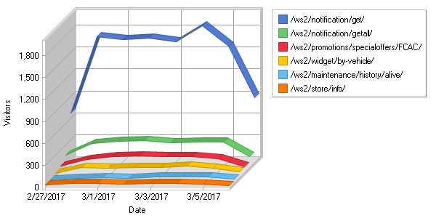

**Top Entry Pages**  
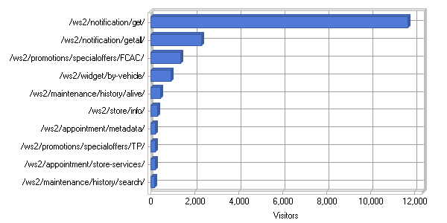

**Top Entry Pages**

|  |
| --- |
|  |

|  |  |  |  |  |  |  |  |  |  |  |  |  |  |  |  |  |  |  |  |  |  |  |  |  |  |  |  |  |  |  |  |  |  |  |  |  |  |  |  |  |  |  |  |  |  |  |  |  |  |  |  |  |  |  |  |  |  |  |  |  |  |  |  |  |  |  |  |  |  |  |  |  |  |  |  |  |  |  |  |  |  |  |  |  |  |  |  |  |  |  |  |  |  |  |  |  |  |  |  |  |  |  |  |  |  |  |  |  |  |  |  |  |  |  |  |  |  |  |  |  |  |  |  |  |  |  |  |  |  |  |  |  |  |  |  |  |  |  |  |  |  |  |  |  |  |  |  |  |  |  |  |  |  |  |  |  |  |  |  |
| --- | --- | --- | --- | --- | --- | --- | --- | --- | --- | --- | --- | --- | --- | --- | --- | --- | --- | --- | --- | --- | --- | --- | --- | --- | --- | --- | --- | --- | --- | --- | --- | --- | --- | --- | --- | --- | --- | --- | --- | --- | --- | --- | --- | --- | --- | --- | --- | --- | --- | --- | --- | --- | --- | --- | --- | --- | --- | --- | --- | --- | --- | --- | --- | --- | --- | --- | --- | --- | --- | --- | --- | --- | --- | --- | --- | --- | --- | --- | --- | --- | --- | --- | --- | --- | --- | --- | --- | --- | --- | --- | --- | --- | --- | --- | --- | --- | --- | --- | --- | --- | --- | --- | --- | --- | --- | --- | --- | --- | --- | --- | --- | --- | --- | --- | --- | --- | --- | --- | --- | --- | --- | --- | --- | --- | --- | --- | --- | --- | --- | --- | --- | --- | --- | --- | --- | --- | --- | --- | --- | --- | --- | --- | --- | --- | --- | --- | --- | --- | --- | --- | --- | --- | --- | --- | --- | --- | --- | --- | --- |
| |  |  |  | | --- | --- | --- | |  | **Page** | **Visitors** | | 1 | [http://www.api-aem.bsro.com/ ws2/notification/get/](http://www.api-aem.bsro.com/ws2/notification/get/) | 11,704 | | 2 | [http://www.api-aem.bsro.com/ ws2/notification/getall/](http://www.api-aem.bsro.com/ws2/notification/getall/) | 2,321 | | 3 | [http://www.api-aem.bsro.com/ ws2/promotions/specialoffers/ FCAC/](http://www.api-aem.bsro.com/ws2/promotions/specialoffers/FCAC/) | 1,353 | | 4 | [http://www.api-aem.bsro.com/ ws2/widget/by-vehicle/](http://www.api-aem.bsro.com/ws2/widget/by-vehicle/) | 903 | | 5 | [http://www.api-aem.bsro.com/ ws2/maintenance/history/ alive/](http://www.api-aem.bsro.com/ws2/maintenance/history/alive/) | 429 | | 6 | [http://www.api-aem.bsro.com/ ws2/store/info/](http://www.api-aem.bsro.com/ws2/store/info/) | 299 | | 7 | [http://www.api-aem.bsro.com/ ws2/appointment/metadata/](http://www.api-aem.bsro.com/ws2/appointment/metadata/) | 205 | | 8 | [http://www.api-aem.bsro.com/ ws2/promotions/specialoffers/TP/](http://www.api-aem.bsro.com/ws2/promotions/specialoffers/TP/) | 199 | | 9 | [http://www.api-aem.bsro.com/ ws2/appointment/store-services/](http://www.api-aem.bsro.com/ws2/appointment/store-services/) | 190 | | 10 | [http://www.api-aem.bsro.com/ ws2/maintenance/history/ search/](http://www.api-aem.bsro.com/ws2/maintenance/history/search/) | 153 | | 11 | [http://www.api-aem.bsro.com/ ws2/mobile-app-user/authenticate/](http://www.api-aem.bsro.com/ws2/mobile-app-user/authenticate/) | 110 | | 12 | [http://www.api-aem.bsro.com/ ws2/contact/save-wifi-contact/](http://www.api-aem.bsro.com/ws2/contact/save-wifi-contact/) | 91 | | 13 | [http://www.api-aem.bsro.com/ ws2/appointment/availability/ days/](http://www.api-aem.bsro.com/ws2/appointment/availability/days/) | 79 | | 14 | [http://www.api-aem.bsro.com/ ws2/notification/update/](http://www.api-aem.bsro.com/ws2/notification/update/) | 78 | | 15 | [http://www.api-aem.bsro.com/ ws2/appointment/availability/ times/](http://www.api-aem.bsro.com/ws2/appointment/availability/times/) | 44 | | 16 | [http://www.api-aem.bsro.com/ ws2/mobile-app-user/register/](http://www.api-aem.bsro.com/ws2/mobile-app-user/register/) | 39 | | 17 | [http://www.api-aem.bsro.com/ ws2/ipinfo/ip/](http://www.api-aem.bsro.com/ws2/ipinfo/ip/) | 39 | | 18 | [http://www.api-aem.bsro.com/ ws2/store/locator/zip/ 18540/FCAC/](http://www.api-aem.bsro.com/ws2/store/locator/zip/18540/FCAC/) | 38 | | 19 | [http://www.api-aem.bsro.com/ ws2/mobile-app-user/forgot-password/](http://www.api-aem.bsro.com/ws2/mobile-app-user/forgot-password/) | 34 | | 20 | [http://www.api-aem.bsro.com/ ws2/store/locator/zip/ 60605/FCAC/](http://www.api-aem.bsro.com/ws2/store/locator/zip/60605/FCAC/) | 31 | | 21 | <http://www.api-aem.bsro.com/> | 31 | | 22 | [http://www.api-aem.bsro.com/ ws2/store/locator/address/ FCAC/](http://www.api-aem.bsro.com/ws2/store/locator/address/FCAC/) | 27 | | 23 | [http://www.api-aem.bsro.com/ ws2/widget/by-vehicle/ 2012/](http://www.api-aem.bsro.com/ws2/widget/by-vehicle/2012/) | 19 | | 24 | [http://www.api-aem.bsro.com/ ws2/widget/by-vehicle/ 2010/](http://www.api-aem.bsro.com/ws2/widget/by-vehicle/2010/) | 18 | | 25 | [http://www.api-aem.bsro.com/ ws2/widget/by-vehicle/ 2005/](http://www.api-aem.bsro.com/ws2/widget/by-vehicle/2005/) | 18 | | 26 | [http://www.api-aem.bsro.com/ ws2/widget/by-vehicle/ 2014/](http://www.api-aem.bsro.com/ws2/widget/by-vehicle/2014/) | 17 | | 27 | [http://www.api-aem.bsro.com/ ws2/widget/by-vehicle/ 2006/](http://www.api-aem.bsro.com/ws2/widget/by-vehicle/2006/) | 17 | | 28 | [http://www.api-aem.bsro.com/ ws2/widget/by-vehicle/ 2013/](http://www.api-aem.bsro.com/ws2/widget/by-vehicle/2013/) | 16 | | 29 | [http://www.api-aem.bsro.com/ ws2/widget/by-vehicle/ 2011/](http://www.api-aem.bsro.com/ws2/widget/by-vehicle/2011/) | 15 | | 30 | [http://www.api-aem.bsro.com/ ws2/widget/by-vehicle/ 2008/](http://www.api-aem.bsro.com/ws2/widget/by-vehicle/2008/) | 14 | | 31 | [http://www.api-aem.bsro.com/ ws2/appointment/book/](http://www.api-aem.bsro.com/ws2/appointment/book/) | 14 | | 32 | [http://www.api-aem.bsro.com/ ws2/widget/by-vehicle/ 2016/](http://www.api-aem.bsro.com/ws2/widget/by-vehicle/2016/) | 13 | | 33 | [http://www.api-aem.bsro.com/ ws2/widget/by-vehicle/ 2007/](http://www.api-aem.bsro.com/ws2/widget/by-vehicle/2007/) | 13 | | 34 | [http://www.api-aem.bsro.com/ ws2/widget/by-vehicle/ 2003/](http://www.api-aem.bsro.com/ws2/widget/by-vehicle/2003/) | 11 | | 35 | [http://www.api-aem.bsro.com/ ws2/widget/by-vehicle/ 2004/](http://www.api-aem.bsro.com/ws2/widget/by-vehicle/2004/) | 11 | | 36 | [http://www.api-aem.bsro.com/ ws2/widget/by-vehicle/ 2015/](http://www.api-aem.bsro.com/ws2/widget/by-vehicle/2015/) | 10 | | 37 | [http://www.api-aem.bsro.com/ ws2/widget/by-vehicle/ 2009/](http://www.api-aem.bsro.com/ws2/widget/by-vehicle/2009/) | 10 | | 38 | [http://www.api-aem.bsro.com/ ws2/tires/pricing/results/](http://www.api-aem.bsro.com/ws2/tires/pricing/results/) | 9 | | 39 | [http://www.api-aem.bsro.com/ ws2/widget/by-vehicle/ 2002/](http://www.api-aem.bsro.com/ws2/widget/by-vehicle/2002/) | 8 | | 40 | [http://www.api-aem.bsro.com/ ws2/widget/by-vehicle/ 2001/](http://www.api-aem.bsro.com/ws2/widget/by-vehicle/2001/) | 8 | | 41 | [http://www.api-aem.bsro.com/ ws2/widget/by-vehicle/ 2000/](http://www.api-aem.bsro.com/ws2/widget/by-vehicle/2000/) | 8 | | 42 | [http://www.api-aem.bsro.com/ ws2/widget/by-vehicle/ 1999/](http://www.api-aem.bsro.com/ws2/widget/by-vehicle/1999/) | 8 | | 43 | [http://www.api-aem.bsro.com/ ws2/widget/by-vehicle/ 1997/](http://www.api-aem.bsro.com/ws2/widget/by-vehicle/1997/) | 8 | | 44 | [http://www.api-aem.bsro.com/ ws2/store/info/FCAC-MVAN/](http://www.api-aem.bsro.com/ws2/store/info/FCAC-MVAN/) | 6 | | 45 | [http://www.api-aem.bsro.com/ ws2/notification/delete/](http://www.api-aem.bsro.com/ws2/notification/delete/) | 5 | | 46 | [http://www.api-aem.bsro.com/ ws2/mobile-app-user/check-data/](http://www.api-aem.bsro.com/ws2/mobile-app-user/check-data/) | 5 | | 47 | [http://www.api-aem.bsro.com/ ws2/store/info/TP-TPL/](http://www.api-aem.bsro.com/ws2/store/info/TP-TPL/) | 5 | | 48 | [http://www.api-aem.bsro.com/ ws2/store/locator/zip/ 20147/WWT/](http://www.api-aem.bsro.com/ws2/store/locator/zip/20147/WWT/) | 4 | | 49 | [http://www.api-aem.bsro.com/ ws2/mobile-app-user/update/](http://www.api-aem.bsro.com/ws2/mobile-app-user/update/) | 4 | | 50 | [http://www.api-aem.bsro.com/ ws2/mobile-app-user/backup/](http://www.api-aem.bsro.com/ws2/mobile-app-user/backup/) | 4 | |  | **Subtotal** | **18,695** | |  | **Total** | **19,951** | |

|  |  |  |
| --- | --- | --- |
| C:\ProgramData\WebLog Expert Lite\Report\index_files\section_left.gif | **Hosts** | C:\ProgramData\WebLog Expert Lite\Report\index_files\section_right.gif |

**Top Hosts**

|  |
| --- |
|  |

|  |  |  |  |  |  |  |  |  |  |  |  |  |  |  |  |  |  |  |  |  |  |  |  |  |  |  |  |  |  |  |  |  |  |  |  |  |  |  |  |  |  |  |  |  |  |  |  |  |  |  |  |  |  |  |  |  |  |  |  |  |  |  |  |  |  |  |  |  |  |  |  |  |  |  |  |  |  |  |  |  |  |  |  |  |  |  |  |  |  |  |  |  |  |  |  |  |  |  |  |  |  |  |  |  |  |  |  |  |  |  |  |  |  |  |  |  |  |  |  |  |  |  |  |  |  |  |  |  |  |  |  |  |  |  |  |  |  |  |  |  |  |  |  |  |  |  |  |  |  |  |  |  |  |  |  |  |  |  |  |  |  |  |  |  |  |  |  |  |  |  |  |  |  |  |  |  |  |  |  |  |  |  |  |  |  |  |  |  |  |  |  |  |  |  |  |  |  |  |  |  |  |  |  |  |  |  |  |  |  |  |  |  |  |  |  |  |  |  |  |  |  |  |  |  |  |  |  |  |  |  |  |  |  |  |  |  |  |  |  |  |  |  |  |  |  |  |  |  |  |  |  |  |  |  |  |  |  |  |  |  |  |  |  |  |  |
| --- | --- | --- | --- | --- | --- | --- | --- | --- | --- | --- | --- | --- | --- | --- | --- | --- | --- | --- | --- | --- | --- | --- | --- | --- | --- | --- | --- | --- | --- | --- | --- | --- | --- | --- | --- | --- | --- | --- | --- | --- | --- | --- | --- | --- | --- | --- | --- | --- | --- | --- | --- | --- | --- | --- | --- | --- | --- | --- | --- | --- | --- | --- | --- | --- | --- | --- | --- | --- | --- | --- | --- | --- | --- | --- | --- | --- | --- | --- | --- | --- | --- | --- | --- | --- | --- | --- | --- | --- | --- | --- | --- | --- | --- | --- | --- | --- | --- | --- | --- | --- | --- | --- | --- | --- | --- | --- | --- | --- | --- | --- | --- | --- | --- | --- | --- | --- | --- | --- | --- | --- | --- | --- | --- | --- | --- | --- | --- | --- | --- | --- | --- | --- | --- | --- | --- | --- | --- | --- | --- | --- | --- | --- | --- | --- | --- | --- | --- | --- | --- | --- | --- | --- | --- | --- | --- | --- | --- | --- | --- | --- | --- | --- | --- | --- | --- | --- | --- | --- | --- | --- | --- | --- | --- | --- | --- | --- | --- | --- | --- | --- | --- | --- | --- | --- | --- | --- | --- | --- | --- | --- | --- | --- | --- | --- | --- | --- | --- | --- | --- | --- | --- | --- | --- | --- | --- | --- | --- | --- | --- | --- | --- | --- | --- | --- | --- | --- | --- | --- | --- | --- | --- | --- | --- | --- | --- | --- | --- | --- | --- | --- | --- | --- | --- | --- | --- | --- | --- | --- | --- | --- | --- | --- | --- | --- | --- | --- | --- | --- | --- | --- | --- | --- | --- | --- | --- | --- | --- | --- | --- | --- | --- | --- | --- | --- | --- |
| |  |  |  |  |  | | --- | --- | --- | --- | --- | |  | **Host** | **Hits** | **Visitors** | **Bandwidth (KB)** | | 1 | 52.22.86.170 | 5,173,631 | 207 | 13,156,457 | | 2 | 52.23.115.213 | 446 | 156 | 879 | | 3 | 63.137.180.3 | 542 | 70 | 85 | | 4 | 66.175.209.119 | 993 | 30 | 0 | | 5 | 54.214.23.0 | 1,001 | 25 | 0 | | 6 | 59.144.135.7 | 242 | 23 | 1,568 | | 7 | 66.175.216.150 | 994 | 23 | 0 | | 8 | 121.244.41.21 | 118 | 23 | 7,406 | | 9 | 50.18.110.134 | 1,035 | 22 | 0 | | 10 | 96.126.120.145 | 1,046 | 20 | 0 | | 11 | 50.116.43.60 | 1,026 | 18 | 0 | | 12 | 54.83.58.21 | 1,011 | 17 | 0 | | 13 | 107.143.74.144 | 42 | 11 | 11 | | 14 | 199.48.25.10 | 89 | 10 | 123 | | 15 | 216.231.193.37 | 32 | 10 | 42 | | 16 | 76.125.221.193 | 53 | 10 | 45 | | 17 | 73.176.24.154 | 67 | 9 | 69 | | 18 | 52.5.157.25 | 68 | 9 | 946 | | 19 | 64.244.196.199 | 28 | 8 | 411 | | 20 | 74.66.228.24 | 33 | 8 | 72 | | 21 | 174.238.14.167 | 18 | 8 | 13 | | 22 | 107.77.161.4 | 42 | 8 | 7 | | 23 | 107.77.161.3 | 36 | 7 | 6 | | 24 | 130.211.176.107 | 12 | 7 | 2,400 | | 25 | 75.128.254.91 | 42 | 7 | 116 | | 26 | 70.196.2.73 | 15 | 7 | 2 | | 27 | 74.96.163.194 | 14 | 6 | 9 | | 28 | 108.22.89.123 | 50 | 6 | 35 | | 29 | 73.252.152.166 | 23 | 6 | 54 | | 30 | 107.77.94.29 | 13 | 6 | 13 | | 31 | 72.193.143.16 | 27 | 6 | 53 | | 32 | 73.40.128.218 | 14 | 6 | 3 | | 33 | 198.101.252.8 | 6 | 6 | 10,979 | | 34 | 66.87.73.102 | 18 | 6 | 5 | | 35 | 174.193.147.86 | 19 | 6 | 2 | | 36 | 166.137.10.120 | 26 | 6 | 3 | | 37 | 173.49.200.112 | 19 | 6 | 3 | | 38 | 107.72.164.93 | 17 | 6 | 1 | | 39 | 24.14.85.195 | 21 | 6 | 2 | | 40 | 67.7.193.130 | 19 | 5 | 59 | | 41 | 66.87.115.70 | 13 | 5 | 5 | | 42 | 172.56.30.152 | 30 | 5 | 7 | | 43 | 172.58.40.29 | 18 | 5 | 1 | | 44 | 107.77.169.2 | 17 | 5 | 17 | | 45 | 107.77.169.5 | 18 | 5 | 48 | | 46 | 107.77.208.98 | 20 | 5 | 6 | | 47 | 107.77.94.50 | 9 | 5 | 0 | | 48 | 66.87.65.145 | 13 | 5 | 3 | | 49 | 73.117.53.246 | 23 | 5 | 5 | | 50 | 166.137.242.125 | 10 | 5 | 0 | |  | **Subtotal** | **5,183,119** | **886** | **13,181,994** | |  | **Total** | **5,283,168** | **20,371** | **13,269,447** | |

|  |  |  |
| --- | --- | --- |
| C:\ProgramData\WebLog Expert Lite\Report\index_files\section_left.gif | **Referring Sites** | C:\ProgramData\WebLog Expert Lite\Report\index_files\section_right.gif |

**Daily Referring Sites**  
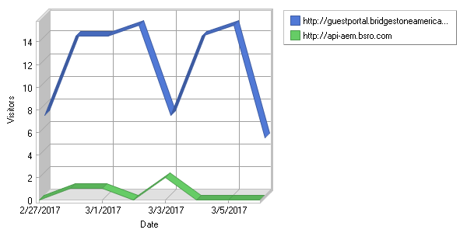

**Top Referring Sites**  
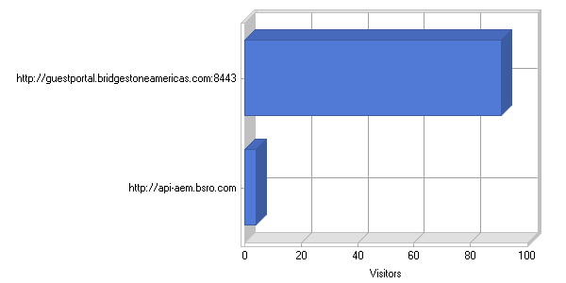

**Top Referring Sites**

|  |
| --- |
|  |

|  |  |  |  |  |  |  |  |  |  |  |  |  |  |  |  |
| --- | --- | --- | --- | --- | --- | --- | --- | --- | --- | --- | --- | --- | --- | --- | --- |
| |  |  |  | | --- | --- | --- | |  | **Site** | **Visitors** | | 1 | No Referrer | 20,276 | | 2 | [http://guestportal.bridgestoneamericas.com:8443](http://guestportal.bridgestoneamericas.com:8443/) | 91 | | 3 | [http://api-aem.bsro.com](http://api-aem.bsro.com/) | 4 | |  | **Total** | **20,371** | |

|  |  |  |
| --- | --- | --- |
| C:\ProgramData\WebLog Expert Lite\Report\index_files\section_left.gif | **Referring URLs** | C:\ProgramData\WebLog Expert Lite\Report\index_files\section_right.gif |

**Daily Referring URLs**  
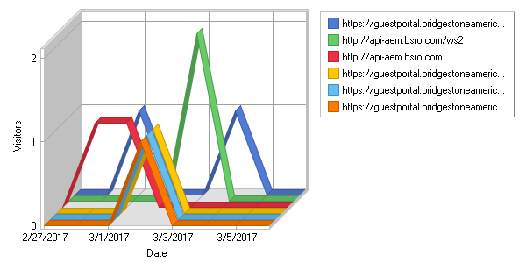

**Top Referring URLs**  
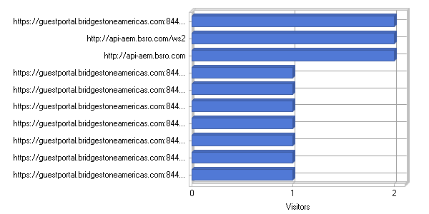

**Top Referring URLs**

|  |
| --- |
|  |

|  |  |  |  |  |  |  |  |  |  |  |  |  |  |  |  |  |  |  |  |  |  |  |  |  |  |  |  |  |  |  |  |  |  |  |  |  |  |  |  |  |  |  |  |  |  |  |  |  |  |  |  |  |  |  |  |  |  |  |  |  |  |  |  |  |  |  |  |  |  |  |  |  |  |  |  |  |  |  |  |  |  |  |  |  |  |  |  |  |  |  |  |  |  |  |  |  |  |  |  |  |  |  |  |  |  |  |  |  |  |  |  |  |  |  |  |  |  |  |  |  |  |  |  |  |  |  |  |  |  |  |  |  |  |  |  |  |  |  |  |  |  |  |  |  |  |  |  |  |  |  |  |  |  |  |  |  |  |  |  |
| --- | --- | --- | --- | --- | --- | --- | --- | --- | --- | --- | --- | --- | --- | --- | --- | --- | --- | --- | --- | --- | --- | --- | --- | --- | --- | --- | --- | --- | --- | --- | --- | --- | --- | --- | --- | --- | --- | --- | --- | --- | --- | --- | --- | --- | --- | --- | --- | --- | --- | --- | --- | --- | --- | --- | --- | --- | --- | --- | --- | --- | --- | --- | --- | --- | --- | --- | --- | --- | --- | --- | --- | --- | --- | --- | --- | --- | --- | --- | --- | --- | --- | --- | --- | --- | --- | --- | --- | --- | --- | --- | --- | --- | --- | --- | --- | --- | --- | --- | --- | --- | --- | --- | --- | --- | --- | --- | --- | --- | --- | --- | --- | --- | --- | --- | --- | --- | --- | --- | --- | --- | --- | --- | --- | --- | --- | --- | --- | --- | --- | --- | --- | --- | --- | --- | --- | --- | --- | --- | --- | --- | --- | --- | --- | --- | --- | --- | --- | --- | --- | --- | --- | --- | --- | --- | --- | --- | --- | --- | --- |
| |  |  |  | | --- | --- | --- | |  | **URL** | **Visitors** | | 1 | No Referrer | 20,276 | | 2 | [https://guestportal.bridgestoneamericas.com:8443/ guestportal/portals/FirestonePortal/ success.html](https://guestportal.bridgestoneamericas.com:8443/guestportal/portals/FirestonePortal/success.html) | 2 | | 3 | <http://api-aem.bsro.com/ws2> | 2 | | 4 | [http://api-aem.bsro.com](http://api-aem.bsro.com/) | 2 | | 5 | [https://guestportal.bridgestoneamericas.com:8443/ guestportal/Login.action? portalname=TiresPlusPortal& sessionId=c200710a019809a2c647b858](https://guestportal.bridgestoneamericas.com:8443/guestportal/Login.action?portalname=TiresPlusPortal&sessionId=c200710a019809a2c647b858) | 1 | | 6 | [https://guestportal.bridgestoneamericas.com:8443/ guestportal/Login.action? portalname=TiresPlusPortal& sessionId=c200710a01980c2d6448b858](https://guestportal.bridgestoneamericas.com:8443/guestportal/Login.action?portalname=TiresPlusPortal&sessionId=c200710a01980c2d6448b858) | 1 | | 7 | [https://guestportal.bridgestoneamericas.com:8443/ guestportal/Login.action? portalname=TiresPlusPortal& sessionId=c200710a0194a0f5b51bb758](https://guestportal.bridgestoneamericas.com:8443/guestportal/Login.action?portalname=TiresPlusPortal&sessionId=c200710a0194a0f5b51bb758) | 1 | | 8 | [https://guestportal.bridgestoneamericas.com:8443/ guestportal/Login.action? portalname=TiresPlusPortal& sessionId=c200710a018fd31b7c90b558](https://guestportal.bridgestoneamericas.com:8443/guestportal/Login.action?portalname=TiresPlusPortal&sessionId=c200710a018fd31b7c90b558) | 1 | | 9 | [https://guestportal.bridgestoneamericas.com:8443/ guestportal/Login.action? portalname=TiresPlusPortal& sessionId=c200710a0190808b9ebeb558](https://guestportal.bridgestoneamericas.com:8443/guestportal/Login.action?portalname=TiresPlusPortal&sessionId=c200710a0190808b9ebeb558) | 1 | | 10 | [https://guestportal.bridgestoneamericas.com:8443/ guestportal/Login.action? portalname=TiresPlusPortal& sessionId=c200710a019814f8e84ab858](https://guestportal.bridgestoneamericas.com:8443/guestportal/Login.action?portalname=TiresPlusPortal&sessionId=c200710a019814f8e84ab858) | 1 | | 11 | [https://guestportal.bridgestoneamericas.com:8443/ guestportal/Login.action? portalname=TiresPlusPortal& sessionId=c200710a019fb52dccceba58](https://guestportal.bridgestoneamericas.com:8443/guestportal/Login.action?portalname=TiresPlusPortal&sessionId=c200710a019fb52dccceba58) | 1 | | 12 | [https://guestportal.bridgestoneamericas.com:8443/ guestportal/Login.action? portalname=TiresPlusPortal& sessionId=c200710a01a42e07d055bc58](https://guestportal.bridgestoneamericas.com:8443/guestportal/Login.action?portalname=TiresPlusPortal&sessionId=c200710a01a42e07d055bc58) | 1 | | 13 | [https://guestportal.bridgestoneamericas.com:8443/ guestportal/Login.action? portalname=TiresPlusPortal& sessionId=c200710a019f8c96f5c2ba58](https://guestportal.bridgestoneamericas.com:8443/guestportal/Login.action?portalname=TiresPlusPortal&sessionId=c200710a019f8c96f5c2ba58) | 1 | | 14 | [https://guestportal.bridgestoneamericas.com:8443/ guestportal/Login.action? portalname=TiresPlusPortal& sessionId=c200710a01981a51644cb858](https://guestportal.bridgestoneamericas.com:8443/guestportal/Login.action?portalname=TiresPlusPortal&sessionId=c200710a01981a51644cb858) | 1 | | 15 | [https://guestportal.bridgestoneamericas.com:8443/ guestportal/Login.action? portalname=TiresPlusPortal& sessionId=c200710a019d41db80e2b958](https://guestportal.bridgestoneamericas.com:8443/guestportal/Login.action?portalname=TiresPlusPortal&sessionId=c200710a019d41db80e2b958) | 1 | | 16 | [https://guestportal.bridgestoneamericas.com:8443/ guestportal/Login.action? portalname=FirestonePortal& sessionId=c200710a01a39ade2829bc58](https://guestportal.bridgestoneamericas.com:8443/guestportal/Login.action?portalname=FirestonePortal&sessionId=c200710a01a39ade2829bc58) | 1 | | 17 | [https://guestportal.bridgestoneamericas.com:8443/ guestportal/Login.action? portalname=FirestonePortal& sessionId=c200710a01a42312ff52bc58](https://guestportal.bridgestoneamericas.com:8443/guestportal/Login.action?portalname=FirestonePortal&sessionId=c200710a01a42312ff52bc58) | 1 | | 18 | [https://guestportal.bridgestoneamericas.com:8443/ guestportal/Login.action? portalname=FirestonePortal& sessionId=c200710a01a37a06d01dbc58](https://guestportal.bridgestoneamericas.com:8443/guestportal/Login.action?portalname=FirestonePortal&sessionId=c200710a01a37a06d01dbc58) | 1 | | 19 | [https://guestportal.bridgestoneamericas.com:8443/ guestportal/Login.action? portalname=FirestonePortal& sessionId=c200710a01a1b73d944bbb58](https://guestportal.bridgestoneamericas.com:8443/guestportal/Login.action?portalname=FirestonePortal&sessionId=c200710a01a1b73d944bbb58) | 1 | | 20 | [https://guestportal.bridgestoneamericas.com:8443/ guestportal/Login.action? portalname=FirestonePortal& sessionId=c200710a01a33fe32907bc58](https://guestportal.bridgestoneamericas.com:8443/guestportal/Login.action?portalname=FirestonePortal&sessionId=c200710a01a33fe32907bc58) | 1 | | 21 | [https://guestportal.bridgestoneamericas.com:8443/ guestportal/Login.action? portalname=FirestonePortal& sessionId=c200710a01a4426e4a5bbc58](https://guestportal.bridgestoneamericas.com:8443/guestportal/Login.action?portalname=FirestonePortal&sessionId=c200710a01a4426e4a5bbc58) | 1 | | 22 | [https://guestportal.bridgestoneamericas.com:8443/ guestportal/Login.action? portalname=TiresPlusPortal& sessionId=c200710a018c066eef45b458](https://guestportal.bridgestoneamericas.com:8443/guestportal/Login.action?portalname=TiresPlusPortal&sessionId=c200710a018c066eef45b458) | 1 | | 23 | [https://guestportal.bridgestoneamericas.com:8443/ guestportal/Login.action? portalname=TiresPlusPortal& sessionId=c200710a018c9ceeef6ab458](https://guestportal.bridgestoneamericas.com:8443/guestportal/Login.action?portalname=TiresPlusPortal&sessionId=c200710a018c9ceeef6ab458) | 1 | | 24 | [https://guestportal.bridgestoneamericas.com:8443/ guestportal/Login.action? portalname=TiresPlusPortal& sessionId=c200710a018bfa3b5e42b458](https://guestportal.bridgestoneamericas.com:8443/guestportal/Login.action?portalname=TiresPlusPortal&sessionId=c200710a018bfa3b5e42b458) | 1 | | 25 | [https://guestportal.bridgestoneamericas.com:8443/ guestportal/Login.action? portalname=FirestonePortal& sessionId=c200710a01a5c3a26cd7bc58](https://guestportal.bridgestoneamericas.com:8443/guestportal/Login.action?portalname=FirestonePortal&sessionId=c200710a01a5c3a26cd7bc58) | 1 | | 26 | [https://guestportal.bridgestoneamericas.com:8443/ guestportal/Login.action? portalname=TiresPlusPortal& sessionId=c200710a018b883fb522b458](https://guestportal.bridgestoneamericas.com:8443/guestportal/Login.action?portalname=TiresPlusPortal&sessionId=c200710a018b883fb522b458) | 1 | | 27 | [https://guestportal.bridgestoneamericas.com:8443/ guestportal/LoginCheck.action? sessionId=c200710a019e1ca22d19ba58](https://guestportal.bridgestoneamericas.com:8443/guestportal/LoginCheck.action?sessionId=c200710a019e1ca22d19ba58) | 1 | | 28 | [https://guestportal.bridgestoneamericas.com:8443/ guestportal/LoginCheck.action? sessionId=c200710a019ef29fac79ba58](https://guestportal.bridgestoneamericas.com:8443/guestportal/LoginCheck.action?sessionId=c200710a019ef29fac79ba58) | 1 | | 29 | [https://guestportal.bridgestoneamericas.com:8443/ guestportal/LoginCheck.action? sessionId=c200710a019bd6632e8ab958](https://guestportal.bridgestoneamericas.com:8443/guestportal/LoginCheck.action?sessionId=c200710a019bd6632e8ab958) | 1 | | 30 | [https://guestportal.bridgestoneamericas.com:8443/ guestportal/LoginCheck.action? sessionId=c200710a01970204a1f9b758](https://guestportal.bridgestoneamericas.com:8443/guestportal/LoginCheck.action?sessionId=c200710a01970204a1f9b758) | 1 | | 31 | [https://guestportal.bridgestoneamericas.com:8443/ guestportal/LoginCheck.action? sessionId=c200710a01972e988f0db858](https://guestportal.bridgestoneamericas.com:8443/guestportal/LoginCheck.action?sessionId=c200710a01972e988f0db858) | 1 | | 32 | [https://guestportal.bridgestoneamericas.com:8443/ guestportal/LoginCheck.action? sessionId=c200710a019f0a7d2188ba58](https://guestportal.bridgestoneamericas.com:8443/guestportal/LoginCheck.action?sessionId=c200710a019f0a7d2188ba58) | 1 | | 33 | [https://guestportal.bridgestoneamericas.com:8443/ guestportal/LoginCheck.action? sessionId=c200710a01a2f28a1dd7bb58](https://guestportal.bridgestoneamericas.com:8443/guestportal/LoginCheck.action?sessionId=c200710a01a2f28a1dd7bb58) | 1 | | 34 | [https://guestportal.bridgestoneamericas.com:8443/ guestportal/LoginCheck.action? sessionId=c200710a01a4e2dacc86bc58](https://guestportal.bridgestoneamericas.com:8443/guestportal/LoginCheck.action?sessionId=c200710a01a4e2dacc86bc58) | 1 | | 35 | [https://guestportal.bridgestoneamericas.com:8443/ guestportal/LoginCheck.action? sessionId=c200710a01a1b72e8f4bbb58](https://guestportal.bridgestoneamericas.com:8443/guestportal/LoginCheck.action?sessionId=c200710a01a1b72e8f4bbb58) | 1 | | 36 | [https://guestportal.bridgestoneamericas.com:8443/ guestportal/LoginCheck.action? sessionId=c200710a019f78c702bcba58](https://guestportal.bridgestoneamericas.com:8443/guestportal/LoginCheck.action?sessionId=c200710a019f78c702bcba58) | 1 | | 37 | [https://guestportal.bridgestoneamericas.com:8443/ guestportal/LoginCheck.action? sessionId=c200710a019f9b9b77c7ba58](https://guestportal.bridgestoneamericas.com:8443/guestportal/LoginCheck.action?sessionId=c200710a019f9b9b77c7ba58) | 1 | | 38 | [https://guestportal.bridgestoneamericas.com:8443/ guestportal/LoginCheck.action? sessionId=c200710a018dc6647bb3b458](https://guestportal.bridgestoneamericas.com:8443/guestportal/LoginCheck.action?sessionId=c200710a018dc6647bb3b458) | 1 | | 39 | [https://guestportal.bridgestoneamericas.com:8443/ guestportal/LoginCheck.action? sessionId=c200710a018f2b474f5db558](https://guestportal.bridgestoneamericas.com:8443/guestportal/LoginCheck.action?sessionId=c200710a018f2b474f5db558) | 1 | | 40 | [https://guestportal.bridgestoneamericas.com:8443/ guestportal/LoginCheck.action? sessionId=c200710a018ccf1b6c77b458](https://guestportal.bridgestoneamericas.com:8443/guestportal/LoginCheck.action?sessionId=c200710a018ccf1b6c77b458) | 1 | | 41 | [https://guestportal.bridgestoneamericas.com:8443/ guestportal/LoginCheck.action? sessionId=c200710a018ac932ecc1b358](https://guestportal.bridgestoneamericas.com:8443/guestportal/LoginCheck.action?sessionId=c200710a018ac932ecc1b358) | 1 | | 42 | [https://guestportal.bridgestoneamericas.com:8443/ guestportal/LoginCheck.action? sessionId=c200710a018c6e371b61b458](https://guestportal.bridgestoneamericas.com:8443/guestportal/LoginCheck.action?sessionId=c200710a018c6e371b61b458) | 1 | | 43 | [https://guestportal.bridgestoneamericas.com:8443/ guestportal/LoginCheck.action? sessionId=c200710a018f72385275b558](https://guestportal.bridgestoneamericas.com:8443/guestportal/LoginCheck.action?sessionId=c200710a018f72385275b558) | 1 | | 44 | [https://guestportal.bridgestoneamericas.com:8443/ guestportal/LoginCheck.action? sessionId=c200710a0193f25626f0b658](https://guestportal.bridgestoneamericas.com:8443/guestportal/LoginCheck.action?sessionId=c200710a0193f25626f0b658) | 1 | | 45 | [https://guestportal.bridgestoneamericas.com:8443/ guestportal/LoginCheck.action? sessionId=c200710a01956940be4cb758](https://guestportal.bridgestoneamericas.com:8443/guestportal/LoginCheck.action?sessionId=c200710a01956940be4cb758) | 1 | | 46 | [https://guestportal.bridgestoneamericas.com:8443/ guestportal/LoginCheck.action? sessionId=c200710a0193ec50c5eeb658](https://guestportal.bridgestoneamericas.com:8443/guestportal/LoginCheck.action?sessionId=c200710a0193ec50c5eeb658) | 1 | | 47 | [https://guestportal.bridgestoneamericas.com:8443/ guestportal/LoginCheck.action? sessionId=c200710a0190c2c365cfb558](https://guestportal.bridgestoneamericas.com:8443/guestportal/LoginCheck.action?sessionId=c200710a0190c2c365cfb558) | 1 | | 48 | [https://guestportal.bridgestoneamericas.com:8443/ guestportal/LoginCheck.action? sessionId=c200710a019126a127e7b558](https://guestportal.bridgestoneamericas.com:8443/guestportal/LoginCheck.action?sessionId=c200710a019126a127e7b558) | 1 | | 49 | [https://guestportal.bridgestoneamericas.com:8443/ guestportal/Login.action? portalname=FirestonePortal& sessionId=c200710a019165d2fff5b558](https://guestportal.bridgestoneamericas.com:8443/guestportal/Login.action?portalname=FirestonePortal&sessionId=c200710a019165d2fff5b558) | 1 | | 50 | [https://guestportal.bridgestoneamericas.com:8443/ guestportal/Login.action? portalname=FirestonePortal& sessionId=c200710a01932ecf2fb6b658](https://guestportal.bridgestoneamericas.com:8443/guestportal/Login.action?portalname=FirestonePortal&sessionId=c200710a01932ecf2fb6b658) | 1 | |  | **Subtotal** | **20,328** | |  | **Total** | **20,371** | |

|  |  |  |
| --- | --- | --- |
| C:\ProgramData\WebLog Expert Lite\Report\index_files\section_left.gif | **Browsers** | C:\ProgramData\WebLog Expert Lite\Report\index_files\section_right.gif |

**Daily Used Browsers**  
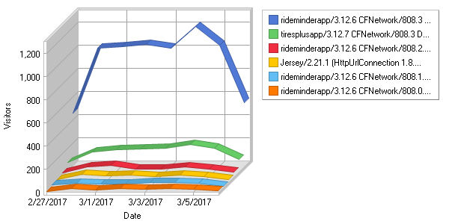

**Most Used Browsers**  
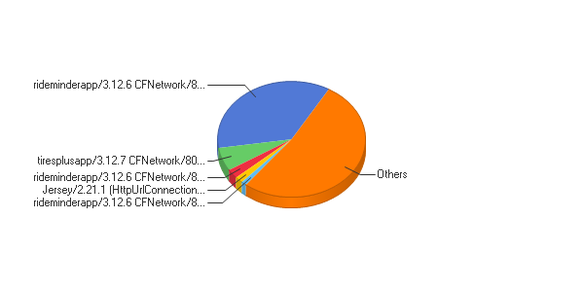

**Most Used Browsers**

|  |
| --- |
|  |

|  |  |  |  |  |  |  |  |  |  |  |  |  |  |  |  |  |  |  |  |  |  |  |  |  |  |  |  |  |  |  |  |  |  |  |  |  |  |  |  |  |  |  |  |  |  |  |  |  |  |  |  |  |  |  |  |  |  |  |  |  |  |  |  |  |  |  |  |  |  |  |  |  |  |  |  |  |  |  |  |  |  |  |  |  |  |  |  |  |  |  |  |  |  |  |  |  |  |  |  |  |  |  |  |  |  |  |  |  |  |  |  |  |  |  |  |  |  |  |  |  |  |  |  |  |  |  |  |  |  |  |  |  |  |  |  |  |  |  |  |  |  |  |  |  |  |  |  |  |  |  |  |  |  |  |  |  |  |  |  |  |  |  |  |  |  |  |  |  |  |  |  |  |  |  |  |  |  |  |  |  |  |  |  |  |  |  |  |  |  |  |  |  |  |  |  |  |  |  |  |  |  |  |  |  |  |  |  |  |  |  |  |  |  |  |  |  |  |  |  |  |  |  |  |  |  |  |  |  |  |  |  |  |  |  |  |  |  |  |  |  |  |  |  |  |  |  |  |  |  |  |  |  |  |  |  |  |  |  |  |  |  |  |  |  |  |
| --- | --- | --- | --- | --- | --- | --- | --- | --- | --- | --- | --- | --- | --- | --- | --- | --- | --- | --- | --- | --- | --- | --- | --- | --- | --- | --- | --- | --- | --- | --- | --- | --- | --- | --- | --- | --- | --- | --- | --- | --- | --- | --- | --- | --- | --- | --- | --- | --- | --- | --- | --- | --- | --- | --- | --- | --- | --- | --- | --- | --- | --- | --- | --- | --- | --- | --- | --- | --- | --- | --- | --- | --- | --- | --- | --- | --- | --- | --- | --- | --- | --- | --- | --- | --- | --- | --- | --- | --- | --- | --- | --- | --- | --- | --- | --- | --- | --- | --- | --- | --- | --- | --- | --- | --- | --- | --- | --- | --- | --- | --- | --- | --- | --- | --- | --- | --- | --- | --- | --- | --- | --- | --- | --- | --- | --- | --- | --- | --- | --- | --- | --- | --- | --- | --- | --- | --- | --- | --- | --- | --- | --- | --- | --- | --- | --- | --- | --- | --- | --- | --- | --- | --- | --- | --- | --- | --- | --- | --- | --- | --- | --- | --- | --- | --- | --- | --- | --- | --- | --- | --- | --- | --- | --- | --- | --- | --- | --- | --- | --- | --- | --- | --- | --- | --- | --- | --- | --- | --- | --- | --- | --- | --- | --- | --- | --- | --- | --- | --- | --- | --- | --- | --- | --- | --- | --- | --- | --- | --- | --- | --- | --- | --- | --- | --- | --- | --- | --- | --- | --- | --- | --- | --- | --- | --- | --- | --- | --- | --- | --- | --- | --- | --- | --- | --- | --- | --- | --- | --- | --- | --- | --- | --- | --- | --- | --- | --- | --- | --- | --- | --- | --- | --- | --- | --- | --- | --- | --- | --- | --- | --- | --- | --- | --- | --- | --- |
| |  |  |  |  |  | | --- | --- | --- | --- | --- | |  | **Browser** | **Hits** | **Visitors** | **% of Total Visitors** | | 1 | Others | 28,576 | 9,033 | 43.62% | | 2 | rideminderapp/3.12.6 CFNetwork/808.3 Darwin/16.3.0 | 28,680 | 7,401 | 35.74% | | 3 | tiresplusapp/3.12.7 CFNetwork/808.3 Darwin/16.3.0 | 5,803 | 1,365 | 6.59% | | 4 | rideminderapp/3.12.6 CFNetwork/808.2.16 Darwin/16.3.0 | 2,230 | 533 | 2.57% | | 5 | Jersey/2.21.1 (HttpUrlConnection 1.8.0\_112) | 5,174,077 | 363 | 1.75% | | 6 | rideminderapp/3.12.6 CFNetwork/808.1.4 Darwin/16.1.0 | 726 | 236 | 1.14% | | 7 | rideminderapp/3.12.6 CFNetwork/808.0.2 Darwin/16.0.0 | 731 | 190 | 0.92% | | 8 | rideminderapp/3.12.6 CFNetwork/758.5.3 Darwin/15.6.0 | 778 | 186 | 0.90% | | 9 | Google Chrome | 20,596 | 90 | 0.43% | | 10 | tiresplusapp/3.12.7 CFNetwork/808.2.16 Darwin/16.3.0 | 266 | 76 | 0.37% | | 11 | rideminderapp/3.11 CFNetwork/808.3 Darwin/16.3.0 | 169 | 74 | 0.36% | | 12 | Apache-HttpClient/4.4.1 (Java/1.8.0\_112) | 506 | 68 | 0.33% | | 13 | Internet Explorer | 1,055 | 53 | 0.26% | | 14 | rideminderapp/3.12.6 CFNetwork/811.4.18 Darwin/16.5.0 | 214 | 51 | 0.25% | | 15 | tiresplusapp/3.12.7 CFNetwork/808.1.4 Darwin/16.1.0 | 273 | 49 | 0.24% | | 16 | rideminderapp/3.12.6 CFNetwork/811.4.16 Darwin/16.5.0 | 171 | 42 | 0.20% | | 17 | rideminderapp/3.12.6 CFNetwork/758.4.3 Darwin/15.5.0 | 135 | 37 | 0.18% | | 18 | tiresplusapp/3.12.7 CFNetwork/758.5.3 Darwin/15.6.0 | 175 | 37 | 0.18% | | 19 | Java/1.8.0\_112 | 104 | 34 | 0.16% | | 20 | tiresplusapp/3.12.7 CFNetwork/808.0.2 Darwin/16.0.0 | 104 | 33 | 0.16% | | 21 | CopperEgg/RevealUptime/NewarkNJUSA | 993 | 30 | 0.14% | | 22 | Mobile Safari | 7,044 | 27 | 0.13% | | 23 | rideminderapp/3.10.0 CFNetwork/808.3 Darwin/16.3.0 | 68 | 26 | 0.13% | | 24 | CopperEgg/RevealUptime/OregonUSA | 1,001 | 25 | 0.12% | | 25 | CopperEgg/RevealUptime/FremontCAUSA | 994 | 23 | 0.11% | | 26 | rideminderapp/3.12.6 CFNetwork/758.2.8 Darwin/15.0.0 | 91 | 23 | 0.11% | | 27 | CopperEgg/RevealUptime/ | 1,035 | 22 | 0.11% | | 28 | CopperEgg/RevealUptime/DallasTXUSA | 1,046 | 20 | 0.10% | | 29 | CopperEgg/RevealUptime/N.VirginiaUSA | 1,013 | 18 | 0.09% | | 30 | rideminderapp/3.12.6 CFNetwork/758.3.15 Darwin/15.4.0 | 48 | 18 | 0.09% | | 31 | CopperEgg/RevealUptime/AtlantaGAUSA | 1,026 | 18 | 0.09% | | 32 | rideminderapp/3.12.6 CFNetwork/672.1.15 Darwin/14.0.0 | 60 | 17 | 0.08% | | 33 | PostmanRuntime/3.0.11-hotfix.2 | 45 | 16 | 0.08% | | 34 | rideminderapp/3.11 CFNetwork/808.2.16 Darwin/16.3.0 | 17 | 14 | 0.07% | | 35 | tiresplusapp/3.12.7 CFNetwork/811.4.16 Darwin/16.5.0 | 40 | 12 | 0.06% | | 36 | rideminderapp/3.12.7 CFNetwork/808.2.16 Darwin/16.0.0 | 61 | 12 | 0.06% | | 37 | rideminderapp/3.8.1 CFNetwork/808.3 Darwin/16.3.0 | 29 | 10 | 0.05% | | 38 | Firefox | 389 | 10 | 0.05% | | 39 | rideminderapp/3.12.6 CFNetwork/758.1.6 Darwin/15.0.0 | 37 | 9 | 0.04% | | 40 | rideminderapp/3.9.0 CFNetwork/808.3 Darwin/16.3.0 | 28 | 8 | 0.04% | | 41 | rideminderapp/3.11 CFNetwork/808.0.2 Darwin/16.0.0 | 10 | 8 | 0.04% | | 42 | Android Browser | 648 | 8 | 0.04% | | 43 | tiresplusapp/3.10.0 CFNetwork/808.3 Darwin/16.3.0 | 23 | 7 | 0.03% | | 44 | rideminderapp/3.12.6 CFNetwork/811.4.14 Darwin/16.5.0 | 15 | 7 | 0.03% | | 45 | tiresplusapp/3.12.7 CFNetwork/758.4.3 Darwin/15.5.0 | 17 | 7 | 0.03% | | 46 | tiresplusapp/3.11 CFNetwork/808.3 Darwin/16.3.0 | 20 | 7 | 0.03% | | 47 | tiresplusapp/3.12.7 CFNetwork/758.2.8 Darwin/15.0.0 | 24 | 7 | 0.03% | | 48 | curl/7.22.0 (x86\_64-pc-linux-gnu) libcurl/7.22.0 OpenSSL/1.0.1 zlib/1.2.3.4 libidn/1.23 librtmp/2.3 | 6 | 6 | 0.03% | | 49 | rideminderapp/3.12.6 CFNetwork/811.4.12 Darwin/16.5.0 | 15 | 6 | 0.03% | | 50 | rideminderapp/3.10.0 CFNetwork/808.0.2 Darwin/16.0.0 | 14 | 6 | 0.03% | |  | **Subtotal** | **5,281,226** | **20,378** | **98.40%** | |  | **Total** | **5,283,168** | **20,709** | **100.00%** | |

|  |  |  |
| --- | --- | --- |
| C:\ProgramData\WebLog Expert Lite\Report\index_files\section_left.gif | **IE and Edge Versions** | C:\ProgramData\WebLog Expert Lite\Report\index_files\section_right.gif |

**Daily Internet Explorer and Microsoft Edge Versions**  
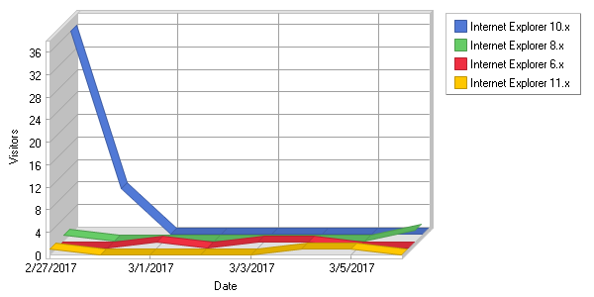

**Internet Explorer and Microsoft Edge Versions**  
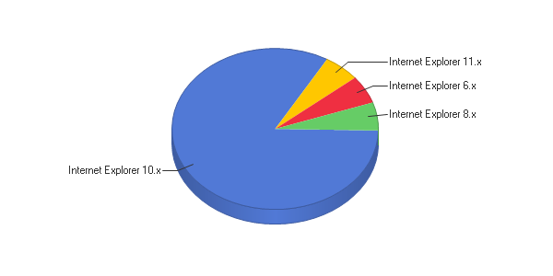

**Internet Explorer and Microsoft Edge Versions**

|  |
| --- |
|  |

|  |  |  |  |  |  |  |  |  |  |  |  |  |  |  |  |  |  |  |  |  |  |  |  |  |  |  |  |  |  |  |  |  |
| --- | --- | --- | --- | --- | --- | --- | --- | --- | --- | --- | --- | --- | --- | --- | --- | --- | --- | --- | --- | --- | --- | --- | --- | --- | --- | --- | --- | --- | --- | --- | --- | --- |
| |  |  |  |  |  | | --- | --- | --- | --- | --- | |  | **Browser** | **Hits** | **Visitors** | **% of Total Visitors** | | 1 | Internet Explorer 10.x | 88 | 44 | 83.02% | | 2 | Internet Explorer 8.x | 3 | 3 | 5.66% | | 3 | Internet Explorer 6.x | 5 | 3 | 5.66% | | 4 | Internet Explorer 11.x | 1,635 | 3 | 5.66% | |  | **Total** | **1,731** | **53** | **100.00%** | | | |
| C:\ProgramData\WebLog Expert Lite\Report\index_files\section_left.gif | **Operating Systems** | C:\ProgramData\WebLog Expert Lite\Report\index_files\section_right.gif |

**Daily Used Operating Systems**  
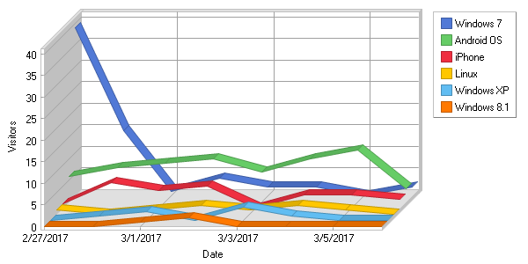

**Most Used Operating Systems**  
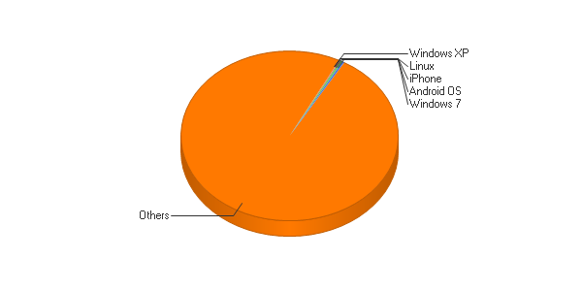

**Most Used Operating Systems**

|  |
| --- |
|  |

|  |  |  |  |  |  |  |  |  |  |  |  |  |  |  |  |  |  |  |  |  |  |  |  |  |  |  |  |  |  |  |  |  |  |  |  |  |  |  |  |  |  |  |  |  |  |  |  |  |  |  |  |  |  |  |  |  |  |  |  |  |  |  |  |  |  |  |  |  |  |  |  |  |  |  |  |  |  |  |  |  |  |  |  |  |  |  |  |  |  |  |
| --- | --- | --- | --- | --- | --- | --- | --- | --- | --- | --- | --- | --- | --- | --- | --- | --- | --- | --- | --- | --- | --- | --- | --- | --- | --- | --- | --- | --- | --- | --- | --- | --- | --- | --- | --- | --- | --- | --- | --- | --- | --- | --- | --- | --- | --- | --- | --- | --- | --- | --- | --- | --- | --- | --- | --- | --- | --- | --- | --- | --- | --- | --- | --- | --- | --- | --- | --- | --- | --- | --- | --- | --- | --- | --- | --- | --- | --- | --- | --- | --- | --- | --- | --- | --- | --- | --- | --- | --- | --- | --- |
| |  |  |  |  |  | | --- | --- | --- | --- | --- | |  | **Operating System** | **Hits** | **Visitors** | **% of Total Visitors** | | 1 | Others | 5,252,063 | 20,193 | 99.13% | | 2 | Windows 7 | 1,186 | 65 | 0.32% | | 3 | Android OS | 19,425 | 65 | 0.32% | | 4 | iPhone | 6,922 | 24 | 0.12% | | 5 | Linux | 44 | 8 | 0.04% | | 6 | Windows XP | 52 | 7 | 0.03% | | 7 | Windows 8.1 | 247 | 3 | 0.01% | | 8 | Mac OS | 554 | 3 | 0.01% | | 9 | Windows 10 | 1,431 | 3 | 0.01% | | 10 | iPod | 105 | 0 | 0.00% | | 11 | iPad | 858 | 0 | 0.00% | | 12 | Windows Vista | 20 | 0 | 0.00% | | 13 | Chrome OS | 108 | 0 | 0.00% | | 14 | BlackBerry | 3 | 0 | 0.00% | | 15 | Windows Phone | 132 | 0 | 0.00% | | 16 | Windows 8 | 18 | 0 | 0.00% | |  | **Total** | **5,283,168** | **20,371** | **100.00%** | |

|  |  |  |
| --- | --- | --- |
| C:\ProgramData\WebLog Expert Lite\Report\index_files\section_left.gif | **Types** | C:\ProgramData\WebLog Expert Lite\Report\index_files\section_right.gif |

**Daily Error Types**  
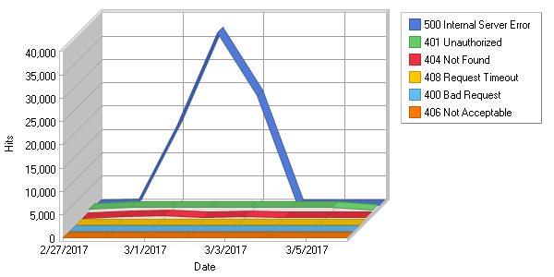

**Error Types**  
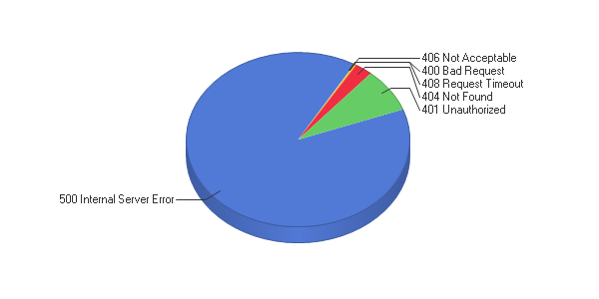

**Error Types**

|  |
| --- |
|  |

|  |  |  |  |  |  |  |  |  |  |  |  |  |  |  |  |  |  |  |  |  |  |  |  |  |
| --- | --- | --- | --- | --- | --- | --- | --- | --- | --- | --- | --- | --- | --- | --- | --- | --- | --- | --- | --- | --- | --- | --- | --- | --- |
| |  |  |  | | --- | --- | --- | |  | **Error** | **Hits** | | 1 | 500 Internal Server Error | 78,191 | | 2 | 401 Unauthorized | 7,121 | | 3 | 404 Not Found | 2,262 | | 4 | 408 Request Timeout | 189 | | 5 | 400 Bad Request | 80 | | 6 | 406 Not Acceptable | 2 | |  | **Total** | **87,845** | |